How to do when U9 network card can not automatically install the driver?
Scene 1: Do not set the computer system to be AutoPlay (Control Panel - AutoPlay – Use AutoPlay for all media and devices). After the card is inserted, the installation prompt will not pop up automatically. You need to install it manually.
Step 1: Manually install the driver.
- Open ‘Computer’, find the ‘CD Drive (E:) Wireless’, click ‘open’.
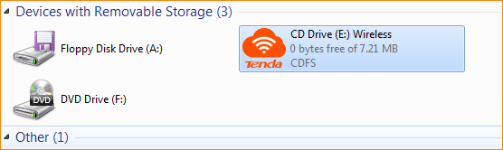

- In the list, double-click the ‘Setup’ application to start installing the driver.
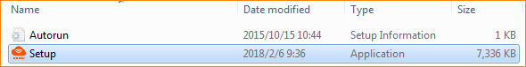
- Wait until the progress bar reaches 100% and then disappear. The driver installation is complete and you can connect the signal to the access the Internet.
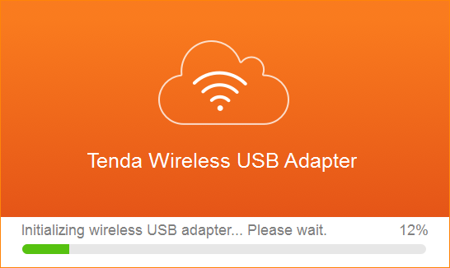
Scene 2: The computer cannot recognize the CD drive. Please refer to the following operation (using Windows 7 as an example):

A, click on the desktop "Start" icon, select the ‘Control Panel’.
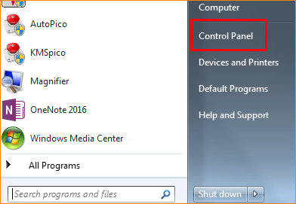

B, Click ‘Uninstall a program’.
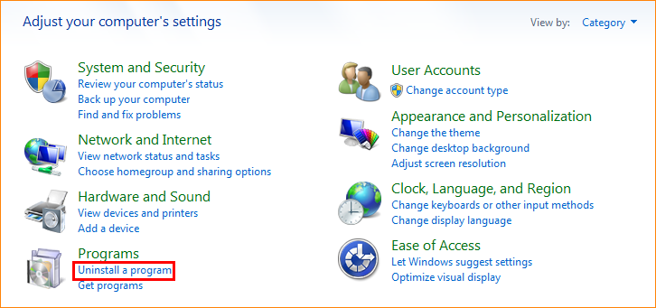

C, find and uninstall other installed drive-free driver of the network card, and then re-insert U9, you can start the installation.

